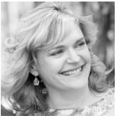 | Linda W. Ferraro, MBA, MS-QSIM,SHRM-SCP  Valency Consulting—Founder & Principal  860.908.0652 | Linda.Ferraro@valencyconsulting.com | www.linkedIn.com/in/valencyconsulting  Leadership Development ■ Team Building ■ Business Metrics ■ Inclusion ■ Executive Coaching ■ HR Consulting ■ Mutual Mentoring ■ Academic/Community Leadership Expertise

\\\\\
Combined Power. Competence. Attraction. In molecular terms, valency is the measure of strength. It represents the degree of positive connectivity and the existence of purposeful bonds. This same attribute exists in business—bottom-line impact is directly correlated to the strength, inclusion, power, and cohesiveness of people and their ability to react, interact, and effect change. Coaching and cultivating these behaviors is at the heart of Valency Consulting’s work.  ■ Talent, Inclusion, & Leadership Development Consultant raising the level of effectiveness of people through culture creation, skill-building and relationships.  ■ Higher Education Professional & Non-Profit Board Leader fostering next generation of OD, HR, and L&D specialists through faculty positions at Eastern Connecticut State University and within community social justice/inclusion groups.  ■ Technical Expert imparting organizational behavior and leadership strategies founded in academic principles from MBA and Doctoral Program coursework specializing in Strategic Decision Making, Innovation, Sustainability, Supply Chain Management, Change Management, and Organizational Development. | Diverse Industry Engagements:  Defense Contracting | Education | Manufacturing | Government | Non Profit | Insurance | Financial Services | Healthcare Consumer Product Goods | Pharma  Sample Fortune 500 Clients:  Barnes Aerospace | Digitas | Electric Boat/General Dynamics | Pfizer | Verizon  UTC Divisions ( Carrier, Collins Aerospace, Pratt & Whitney)  Partnerships & Board Positions:  Leadership Research Institute | Charter Oak Consulting Group | Leading Women Consulting | Writer’s Block | SHRM

Valency Consulting: Pillars of Thought & Key Collaborative Offerings

My passion is to “stretch yourself to grow” as a business leader, people manager, HR driver, community member, or next-generation OD learner. By stretching ourselves, we become stronger, more productive members and contributors to business and society.  Exploring workplace landmarks. Generating new ideas. Figuring out the right questions to ask. I thrive on partnering with others that are curious, fearless, and share a similar commitment to pushing boundaries towards social justice, inclusion, diversity, and change.  Human connections PLUS data insights, digital trends, business analysis, and statistical interpretation are always at the forefront of my transformational change initiatives. | 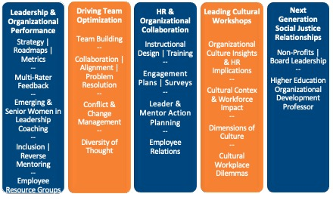

Career Snapshot: Organizational Development | Diversity & Inclusion | Learning | HR Specialist

- Led leadership development program for 500+ UTC managers across U.S., Europe, & Asia focused on team dynamics & change leadership for large-scale projects.
- Board Leader promoting diversity, inclusion, & social justice for Writers Block, Inc. (New London, CT) since 2015.
- Provided OD & leadership capability development support to 1,500+ managers at Hamilton Sundstrand, delivering double-digit increase in survey scores around feedback, goal setting, job growth, & communications.
- Created cutting edge talent assessment & pipeline process for MBA interns at The Hartford. Increased brand recognition, exposure, & competitive edge.
- Designed cross-cultural leadership competency model for 1,100+ managers in the US, UK, & Japan at Pfizer.

